AIMS & OBJECTIVES
- What future forms do you know?
- Which do you usually use?
- What is the difference in meaning between them?
TODAY WE ARE GOING TO:
- Revise common collocations for activities.
- Learn to talk about our hopes for the future.
- Discuss the subtle meaning behind different future forms.
- Make New Year’s Resolutions

SO THAT YOU CAN:
- Talk about your future hopes (e.g. New Year’s resolutions)

NEW YEAR’S RESOLUTIONS
At the beginning of a new year, it is common in some countries to decide on good habits for the year. These are called resolutions. Read the thread about resolutions below. Discuss the questions with your partner.
Notes:

- Is it common to make New Year’s Resolutions in your country?
- Did you make any last year? Did you stick to them?
- Finish the collocations using words from the thread below:
  - Write a __________.
  - Join a ___________.
  - Meet ___________.
  - Get ____________.
  - Start a __________.
- Can you think of any other resolutions to end these collocations?
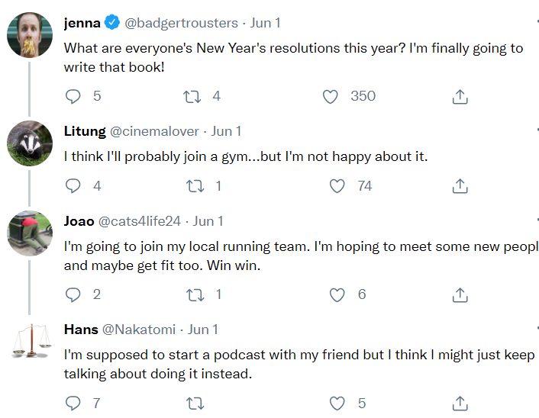

TALKING ABOUT THE FUTURE
Read the thread again. Discuss the questions below with your partner.
- What language do they use to speak about the future?
- Do they use one future form or different ones together?
- Why do these people use these forms in this context? What are they telling people? (write it in your own words).

  - I’m finally going to write that book!
  - I think I’ll probably join a gym.
  - I’m supposed to start a podcast.
  - I think I might just keep talking about it.

In your own words:

NEW YEAR’S RESOLUTIONS
Write your own reply below.
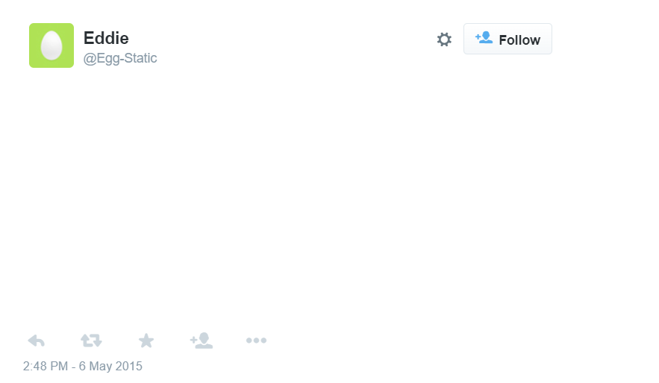

LET’S REFLECT
Discuss the questions below with your partners.
- In what other situations could this language be useful?
- What are your hopes and plans for this weekend?

