AIMS & OBJECTIVES

TODAY WE ARE GOING TO:
- How do you greet people in your culture?
- Is it different for different people (e.g. older/younger)?
- Is there anything you should NOT do when you greet someone?
- Discuss different ways of saying “hello” and “how are you”.
- Speaking skill: Discuss appropriate answers in different cultures.
- Speaking skill: keeping the conversation going
- Speaking skill: learn to show sympathy
- Roleplay the beginning of the class

SO THAT YOU CAN:
- Greet and have short conversations (e.g. with friends, colleagues, classmates from around the world)

SAYING HELLO

Read the comments about greeting below and discuss the questions with your partner:
- Which of these comments are similar / different to how you greet people?
- What do the words in bold mean?
- When we talk about common habits in our culture, we use frequency adverbs (e.g. “often” / “never”). What frequency adverbs can you find in the comments? What do they mean?
- Write your own comment about greeting in your culture in the box.
I normally shake hands when I greet a friend. If we are very close, I might hug them.
In my culture, we usually kiss people on the cheek when we meet them but I don’t really like doing that.
Where I come from, we often wave and say “how are you?” but we don’t expect people to answer honestly.

SPEAKING WITH OTHER CULTURES
Read the speaking tip and discuss the questions with your partners.
Speaking Tip:
In the modern world families, workplaces, and groups of friends often have people from all over the world. Sometimes English is the common language but communicating successfully means understanding each other’s cultures.

- Do you often speak with people from other cultures? How do you greet each other?
- How do you want to be greeted?
- What do you want people from other cultures to think about when they speak with you?


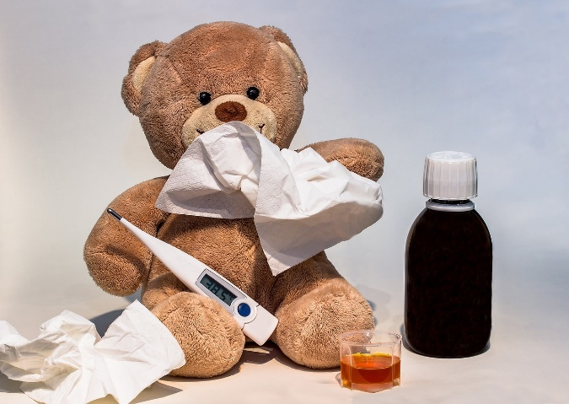
HOW ARE YOU?
Are the statements below true or false for you? Discuss with your partner.

When someone says “how are you?”, I think you should:
- Say you are “fine” even if you are not.
- Always tell the whole truth.
- Tell them about minor illnesses.
- Tell them about serious illnesses.
- Talk about my mental health.
- Ask them how they are.

HOW ARE YOU?
Read the short conversations below and discuss the questions with your partner.
- How many different ways do they ask “how are you?”?
- Do you know any other ways?
- What pieces of language can you take from the conversations and use in your own speaking (e.g. “I can’t complain”).
A: How have you been?
B: Not great. I’ve got a bit of a cold.
A: Oh no, I’m sorry to hear that. Hope you feel better soon.
A: How’s it going?
B: Not bad. A bit tired today but I can’t complain. How about you?
A: Oh really? Bad night’s sleep?
A: How are you doing?
B: Great! The sun is shining. How are you getting on?

SPEAKING SKILL: Responding & showing sympathy
Read the conversations again and discuss the questions with your partner.
- Look up the word “sympathy” in the dictionary. What is the word in your language?
- When do you think it is important to show sympathy?
- Underline when the speakers show sympathy in the conversations.
- Try saying these comments to your partner. How important is intonation and body language when showing sympathy?

SPEAKING
Your going to mingle, greet each other and have short conversations with your classmates. Before you speak, think about:
- How you will greet each other.
- How you will say hello.
- How you will ask them how they are.
- How you will answer how you are.
- How you will show sympathy (word, intonation, body language).
- What language from today you want to use.

