AIMS & OBJECTIVES
- What do you usually write in your language?
- What do you write in English?
- What makes a paragraph easy to follow in your language?
TODAY WE ARE GOING TO:
- Discuss food preferences.
- Read a blog post about food.
- Learn vocabulary related to food tastes.
- Learn to write a paragraph that is easy to follow.
So that you can:
- Write a paragraph that is easy for your reader to follow (e.g. in a blog post about food).
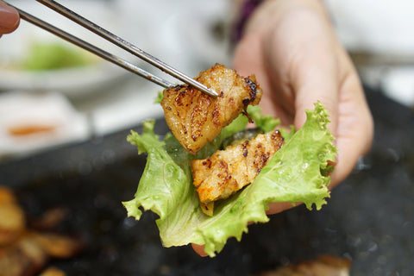
INTRODUCTION
- What is the most delicious thing you’ve eaten or drunk today?
- What do you think the food in the picture is? Would you like to try it?
- What adjectives would you use to describe it?Read the description to check your ideas.

FOOD TASTES
You’re going to tell your partners about the most delicious thing you’ve eaten or drunk this week was. Before you speak, consider:
- Why was it so delicious?
- What adjectives can you use to describe it?
- What language from Vlad’s description can you use?
OMG! I had the most amazing lunch yesterday. I went to a Korean restaurant near work. It was incredible. I had sam-gyup-sal. It was delicious. It’s pork belly that you cook on a barbecue on your table. Then you put it in lettuce with some sauce and some veg. It was crispy, savoury and delicious. I can’t stop thinking about it.
Vlad

READING
Read the title of the blog post on the next page and discuss the questions below. Read the blog post to check your ideas.
- What kind of information do you expect to be in the post?
- What questions do you have about Korean food?
- Do you think this blog will contain formal or informal language?
- Do you think it will contain lots of facts, opinions, or both?

EXPAND YOUR VOCABULARY
Read the title of the blog post again and find the language below:
- Noun: someone who is really interested in food, enjoys new food, and likes discussing food.
- Adjective: many different kinds of.
- Phrase: try something.
- Adjective: kept in a sauce before cooking so that it has a lot of flavour.
- Adjective: well-known

PRACTICE
Text Message:

Write a text message to your friend telling them about something you ate / drank this week.

GRAMMAR FOCUS
The writer uses conditional sentences in the text. Underline them in the text and discuss the questions below with your partner:
- What type of conditional sentence are they? What is the form?
- Why did the writer use these sentences in this text?
- Use a conditional sentence to make a food recommendation for your partner.
A Newcomer to the Delicious World of Korean Food

I like to call myself a foodie but I have to admit that until this year, I had never tried Korean food. I know, it’s hard to believe. Korean cuisine is famous for its unique flavours and diverse dishes. From spicy kimchi to savoury bulgogi, there is something for everyone.

One of my favourite Korean dishes is Bulgogi. If you haven’t tried it, I highly recommend it. Thin slices of marinated beef are grilled to perfection, resulting in tender, sweet, savoury meat. The meat is so tender it melts in your mouth. It's often served with a side of rice and kimchi.

Kimchi is one of the most iconic Korean foods and it tends to be served as a side with most dishes I’ve tried. Made from fermented cabbage, radishes, and spices, it has a strong flavour but I got used to it very quickly. It's not only delicious but also incredibly healthy.

If you want to try something a little different, I would suggest giving bibimbap a go. This colourful dish combines rice, vegetables, and your choice of meat, topped with a spicy gochujang sauce. The fun thing about this dish is that the bowl it is served in is hot so the meat and vegetables continue to cook as you mix them up. It is a wonderful blend of flavours and textures.

If you haven’t tried Korean food yet, then what are you waiting for? If you’re a fan of sweet, savoury, or spicy food, you won’t be disappointed.

WRITING 1: WRITING A PARAGRAPH THAT IS EASY TO FOLLOW
Read the tip box and try to find examples of each of the tips in the blog above.
Writing Tip:
Below are some tips for writing an English paragraph that is easy for a reader to follow:
- The opening sentence should introduce the topic of the sentence.
- The following sentence(s) should expand on the topic of the sentence, giving explanations or examples.
- The final sentence should signal the end of this topic with a final thought.
- The next paragraph should follow on from the final sentence of the previous one by either adding ideas, contrasting with different ideas, or concluding the text.

WRITING 2: Assessing a paragraph
Use the criteria above to assess this paragraph from a food blog. What would you change?
I think many will agree that pizza is one of the greatest, most versatile foods of all time. Pizza is from Italy and many believe if originated in Naples. The last pizza I had was a pepperoni pizza and it was absolutely scrumptious. Pasta is also from Italy and incredibly versatile.

PREPARING TO WRITE & REFLECTING
You’re going to write your own food blog post.
- Before writing, consider:
- What type of food you’re going to talk about.
- What vocabulary from today’s lesson will you use?
- What conditionals will you use?
- After you write, check your paragraphs using the success criteria from the Writing Tip box. Are they easy to follow?

