INTRODUCTION
- How often do you tell stories?
- What kinds of stories do you tell?
- What will be most challenging in today’s lesson?
TODAY WE ARE GOING TO:
- Practise making questions.
- Gather 10-15 common verbs you use every day
- Learn the past simple of the above
- Focus on pronunciation of -ed endings and irregular verbs
- Learn to organise your story so it’s easy to follow.

So that you can:
- Tell a story (e.g. about something you saw / did)

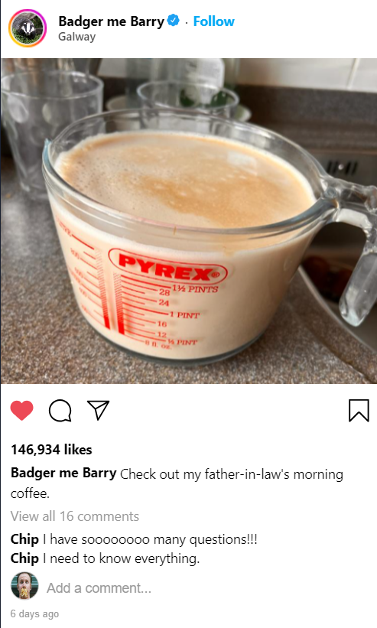
INTRODUCTION
- What are the 10 most common verbs you use every day to talk about your day?
- What did you do yesterday?
- What did you have for breakfast this morning?

INSTAGRAM
Look at the Instagram post and talk about the questions below
- What can you see?
- What questions do you think Chip has? Write them in the box below.
- What do you think the answers to the questions are? Check your ideas on the next page.
- What comment would you leave on this picture?
Questions:

TELLING STORIES
I came downstairs yesterday morning and saw my father-in-law making breakfast. I couldn’t believe my eyes. First he made a pint of coffee and then put in a pint of milk. He poured it into a huge cup and drank half of it. After that, he put it in the microwave to heat it up. Then he drank the second half. It was disgusting.
Barry
Read the comments again and answer the questions.
- What verbs can you find in Barry’s story?
- What 10 verbs do you often use to talk about your day?
- Write your verbs below. Write the present and past of the verb. If you don’t know the past, you can check Barry’s story or look it up online.
- Try to pronounce each of the verbs (past and present) with your partner. Help each other with any difficult sounds.
- Use the verbs to tell your partner about your last weekend.

Come / came

My verbs

ANALYSING LANGUAGE
Read the story again and answer the questions.
- How does Barry say he was surprised?
- Why does Barry use the words: First / then / After that?
- How does Barry finish his story?

SUCCESSFUL SPEAKING
When you tell a story, you should:
- Use the past simple.
- Tell people when the story happened.
- Use “first, then, after that” so your listener can follow your story.
- End your story with an adjective comment. | Can you find examples of each of these in Barry’s story?

PRACTICE & REFLECTION
- Think about something interesting, fun, disgusting, boring that happened to you.
- Plan which verbs you will use to tell the story.
- Plan which words you will use to organise your story so it is easy to follow.
- Tell your partner your story.
- Was your story successful?

