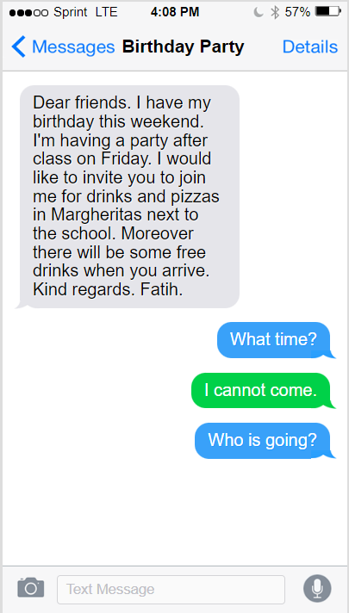
Introduction
Today, we are going to:
- Read a text message conversation.
- Learn to write text messages.
- Learn to talk/write about your plans.
- Learn to refuse an invite politely.
- Learn to ask questions about an invite politely.
So that you can:
- Have a text message conversation (e.g. inviting / refusing / asking questions)

Discuss the questions below with your partner.
- What have you written today?
- Which do you write most in your life, messages, emails, stories, essays?
- What are you doing this weekend?

React to the text
Read the conversation to the right and discuss the questions below with your partner.
- Would you like to join Fatih?
- Why / Why not?
- Is there any other information you’d like to know?
- Write your reply in the green box above.

Focus on Language
- Why does Fatih use the present continuous in this sentence: “I’m having a party on Friday”?
- What are your plans for this weekend?

Analysing a message
Text messages are an example of written spoken-English. Read the conversation again and discuss the questions below with your partner.
- How would you communicate Fatih’s message if you were speaking in person?
- Compare your ideas with Fatih’s message. What is different?
- How would you feel if you were Fatih and you received these replies?
- Read the Text Conversation Analysis to check your ideas.
Text Conversation Analysis:
- Fatih’s text message seems more like an email than a text message. Messages should be more like spoken English than written English. When you’re writing a message to friends, avoid formal language and email openers and closings.
- “What time?” is quite a sudden question. Usually we would start with a comment on the party and then ask questions.
- Usually when we can’t attend an event we reply by apologizing and giving a reason. For example “I’m sorry. I can’t come. I’m having dinner with my parents”. We use the present continuous to show that it is a fixed plan that was organized before.

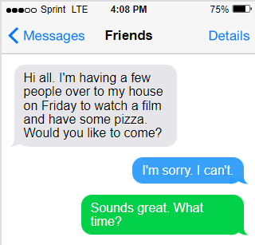
Practice 1
Read the conversation below. Use the Text Conversation Analysis to analyse the conversation.
- Is there anything you would change?
- Write a reply politely saying that you can’t come.
- Write another reply politely asking for more information.

Practice 2
Have a conversation with your partner. In the conversation:
- Explain your plans (using present continuous).
- Invite your partner(s) to join you.
- Turn down invites politely (apologizing and giving excuses with present continuous).
- Ask for more information politely (comment on the event & ask for information).

Reflection
How did you do? Use the criteria above to reflect on how successful you were in your conversation.

