Discussion:
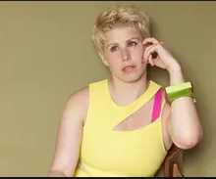
- How equal are the genders in your country?
- What do you know about the #MeToo movement?

Introduction:
- Read the headline to the right. What do you think the article will be about?
- Would you be interested in reading it? Why?
- If you wanted to read this article, what would you Google?
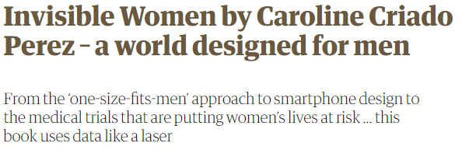

Reading:
Read the introduction to the article.
- Is there anything you would like to Google?
  - Is it specific words?
  - Is it a person who is mentioned?
  - Is it something cultural or something that will help you to understand the article?
  - Do you need to look up every word?
- What is the main point of the introduction?

Reading 2:
Read the second, third and fourth paragraphs of the article.
- Underline the facts in these paragraphs. How do you know they are facts?
- What did you find most interesting?
- How would you report these facts to someone later on?

Useful Phrases (reporting information/responding):
- I come across / read an interesting article the other day. It said…
- I heard / read that…
- Did you hear about…
- That’s terrible / great / amazing / unbelievable.
- What was it about?
Tip: you don’t have to use the exact words from the article! Make it easy

Engaging with the article:
- What did you think of the article? Would you like to read the whole article?
- Did anything surprise you? Is there anything you’d like to know more about?

Language Focus:
Match the meanings on the right with words from the introduction.
The problem with feminism is that it’s just too familiar. The attention of a jaded public and neophiliac media may have been aroused by #MeToo, with its connotations of youth, sex and celebrity, but for the most part it has drifted recently towards other forms of prejudice, such as transphobia. Unfortunately for women, though, the hoary old problems of discrimination, violence and unpaid labour are still very much with us. We mistake our fatigue about feminism for the exhaustion of patriarchy. A recent large survey revealed that more than two thirds of men in Britain believe that women now enjoy equal opportunities. When the writer and activist Caroline Criado Perez campaigned to have a female historical figure on the back of sterling banknotes, one man responded: “But women are everywhere now!”
- Noun: A system of society in which men are in charge:
- Noun: Hatred or dislike of a particular group based on opinions:
- Adj: Bored / lacking enthusiasm
- Adj: obsessed with new things -

Independent Research:
Choose one of the following to Google. Make notes below and then report what you’ve learnt to your partner. Check out the tips box for some research ideas.

Research Tips:
When researching online:
- You don’t need to read everything.
- If something interests you, follow the link. See where it takes you.
- Beware of click bait & advertising banners
- Try reading the headline and the first and last sentence of a paragraph to get a general meaning.
- Caroline Criado Perez
- #MeToo movement
- Instagram ready
- Transphobia
- Campaign for female on banknotes
- Reference man

Notes:

Reflection:
- What interesting facts have you learnt today?
- Is there anything you want to research further?
- What are you going to do with your newfound information?

