Introduction:
- How have reading and writing habits changed in the past 100 years?
- Should written English be formal or informal in your opinion?

Reading:
Skim read the text below and decide if you think it is a modern or an old text. Why do you think this?
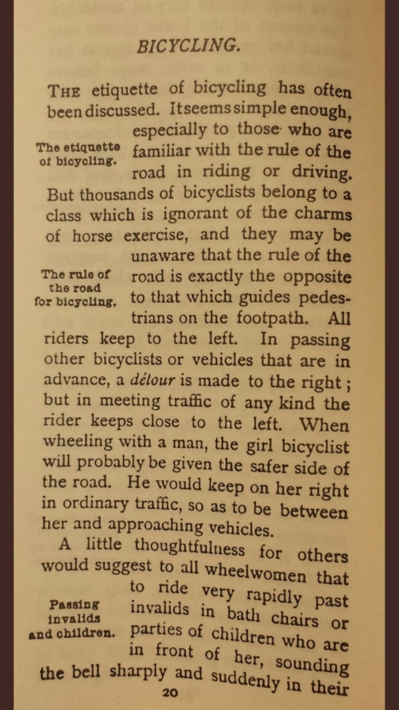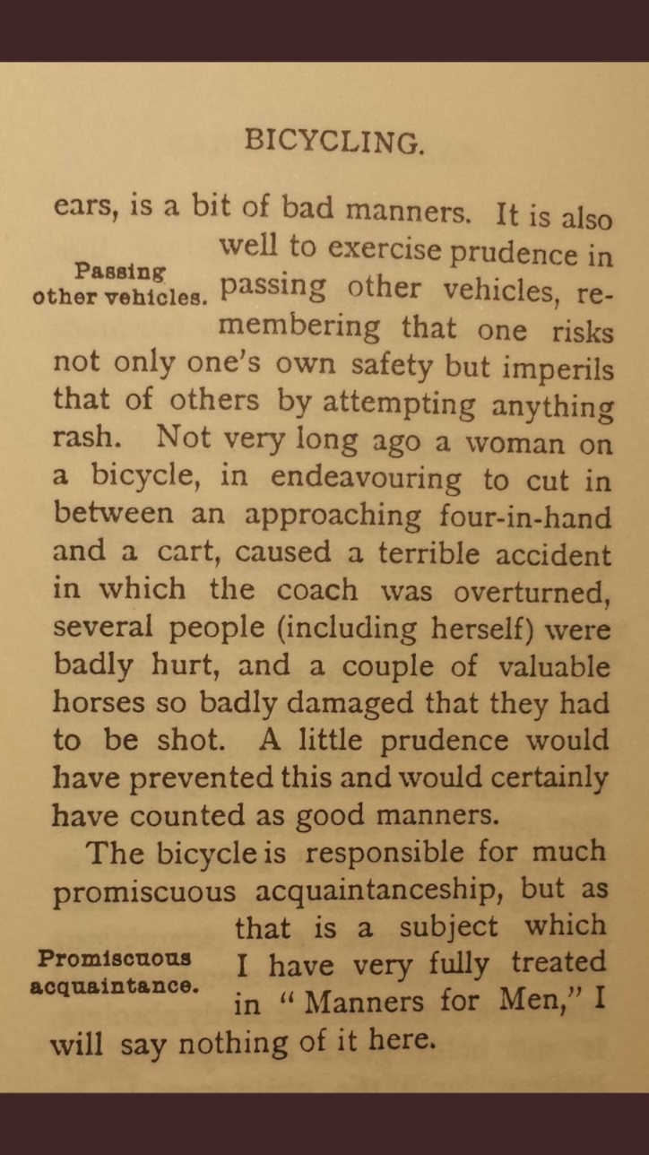
Reading tip:
When reading a text, it’s important to consider the writer’s view of the world. Read the text again, what assumptions can you make about the writer’s world view?
Consider the following lines:
“…thousands of bicyclists belong to a certain class…”
“When wheeling with a man…”
“…much promiscuous acquaintanceship…”

Discussion:
- What do you think of the writer’s view of the world?
- How did you feel after reading the text?
- Can you think of any modern versions of this text?
- Can you find any words in this text that would no longer be in common use?

Language focus (register):
Over the years, English rules for formality have changed. These days, written English (blogs, social media, online articles) tends to be much more conversational. Can you find any sentences in the text that you feel would be totally unnatural in a modern text?
- - - - - - - - - - - - - - -
Can you rewrite the following sections to make them more conversational?:
“It is also well to exercise prudence in passing other vehicles”
“…in endeavouring to cut in between…”
“…one risks not only one’s own safety but imperils that of others…”

Language Focus (analysis):

- Look back at the text, can you identify any language points that are repeated throughout? Is there a reason the author uses them?
- Consider the following two sentences. Why did the author choose “will” and then “would”?
“When wheeling with a man, the girl bicyclist will probably be given the safer side of the ride”
“He would keep her on her right

Writing Task:
Notes:

Imagine flying cars have recently become more commonplace. What would the etiquette be?
You’re going to write an online article for social media.
What will the etiquette be?
Consider the register, will it be formal or conversational?
Will you use “will” or “would”?
Will you use conditional sentences?
Will you use active or passive?

