Introduction:
- How have reading habits changed in the past 100 years?
- If you want instructions, where do you look?
- Would you like to speak / write formal or informal English? Which gives the better impression?

Reading:
Skim read the text below and decide if you think it is a modern or an old text. Why do you think this? The typeface is old-fashioned, the subheadings for the paragraphs are imbedded, which his quite old-fashioned, even the paper is yellowing, the language itself is clearly archaic.
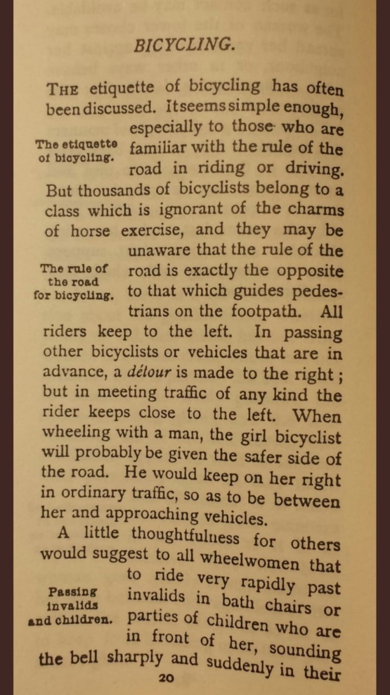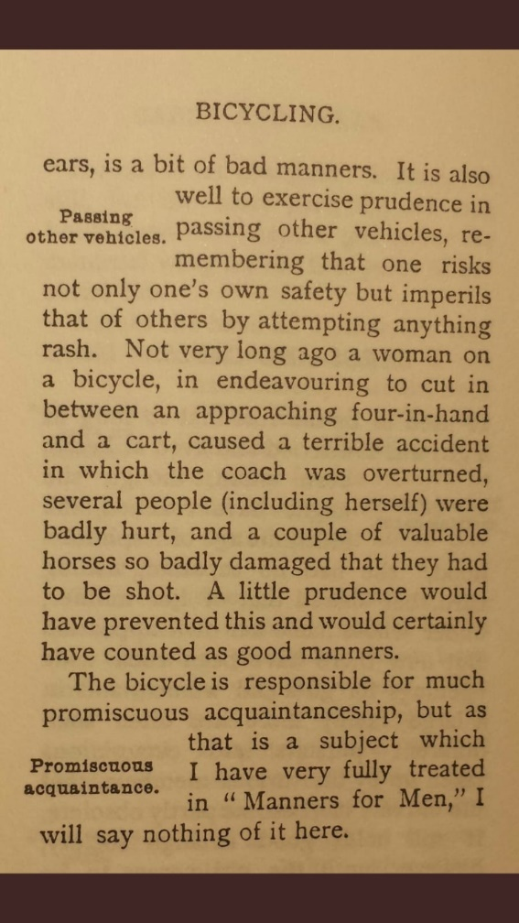
Consider the following lines:
“…thousands of bicyclists belong to a certain class…”
- Somewhat classist. Looking down on working class a bit.
“When wheeling with a man…”
- Women are in need of protection
“…much promiscuous acquaintanceship…”
- There is something almost untoward about bicyclists but its invention has led to greater communication with the outside world.

Discussion:

Language focus (register):
Over the years, English rules for formality have changed. These days, written English (blogs, social media, online articles) tends to be much more conversational. Can you find any sentences in the text that you feel would be totally unnatural in a modern text?
- - - - - - - - - - - - - - -
Can you rewrite the following sections to make them more conversational?:
“It is also well to exercise prudence in passing other vehicles” – You should be careful when overtaking other vehicles
“…in endeavouring to cut in between…” – when trying to cut in between
“…one risks not only one’s own safety but imperils that of others…” – you risk not only your safety but the safety of others

Language Focus (analysis):

- Look back at the text, can you identify any language points that are repeated throughout? Is there a reason the author uses them? Conditional structures / relative clauses / passive voice
- Consider the following two sentences. Why did the author choose “will” and then “would”? – as this is a hypothetical situation but also a possible situation, both are acceptable and possible, depending on what the writer wants to convey
“When wheeling with a man, the girl bicyclist will probably be given the safer side of the ride”
“He would keep her on her right

Writing Task:
Imagine flying cars have recently become more commonplace. What would the etiquette be?
You’re going to write an online article for social media.
What will the etiquette be?
Consider the register, will it be formal or conversational?
Will you use “will” or “would”?
Will you use conditional sentences?
Will you use active or passive?

