Read the text below and with your partner decide what words might fill the gaps.

Back to Work
Lisa was not happy. Her mother was ___________ at work.
Before Lisa was born, her mother worked in a big office. Yesterday, she told Lisa that she was going back to _________.
The morning was terrible. Lisa had to get to school on time. Her father had to get to work on time. And now, her mother was in a _________too.
Lisa’s father made breakfast. It was not too good. And he asked Lisa to wash the ______. That was not too good either.
Lisa did not like her day at school. On the way home, she thought about it. “I wonder what time Mommy will come home. I will be lonely at home.”
But when Lisa arrived at home, there was her ___________. “I leave the office early so we can be together after school,” she said.
Lisa feels fine now.
This text was homework for an 8-year-old girl from New York. When her mother saw it, she was furious so she decided to rewrite the homework assignment.
Discuss the questions below and make some notes in the box.
- Why do you think she felt this way?
- What do you think of the homework?
- What do you think her version of the homework was like?
- What would you change?

Read her mother’s version. Do you like her version? Why? Why not?
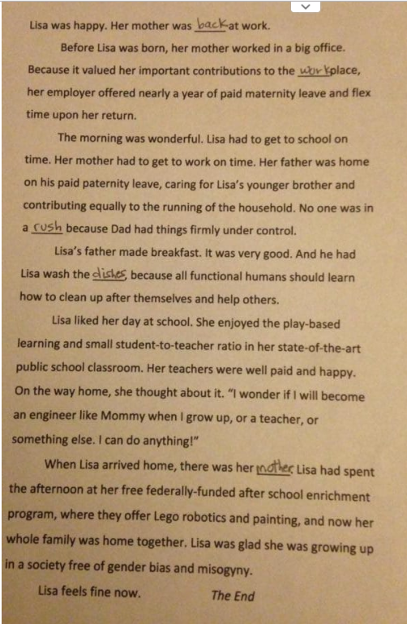
“Her father was on his paid maternity leave, caring for Lisa’s younger brother and contributing equally to the running of the household”
- How many main verbs are there in this sentence?
- Underline the subjects of these verbs.
- Why have they used the “ing” form of “caring” and “contributing”?
- Are there any words missing?
Writing Focus:
- Reread the two texts above. Which text seems more natural when you read it?
- Why do you think that is?
- In general, which text has more simple sentences?
- Examine the sentence in the box to the right and answer the questions.
Vocab Focus:
- Find a synonym for “when”
- What kind of word follows this synonym?
- Do you think it’s more/less formal than “when”?
- What is the difference between “house” “home” and “household”?
- What do you think “state-of-the-art” means?
Dictionary skills:
- Look up “misogyny”. Do you feel the first story was misogynistic?

Preposition Focus:
Cover the text and complete the gaps below. Check your ideas in the text.
- To be back ___ work.
- She made a contribution ___ her workplace.
- She got to work ___ time.
- She always cleaned ___ _____ herself.
- He was ____ paternity leave.

