Examine the advert below and answer the questions
- What is this advertising?
- What can you learn about Wales from this picture?
- Do you think this ad is persuasive?

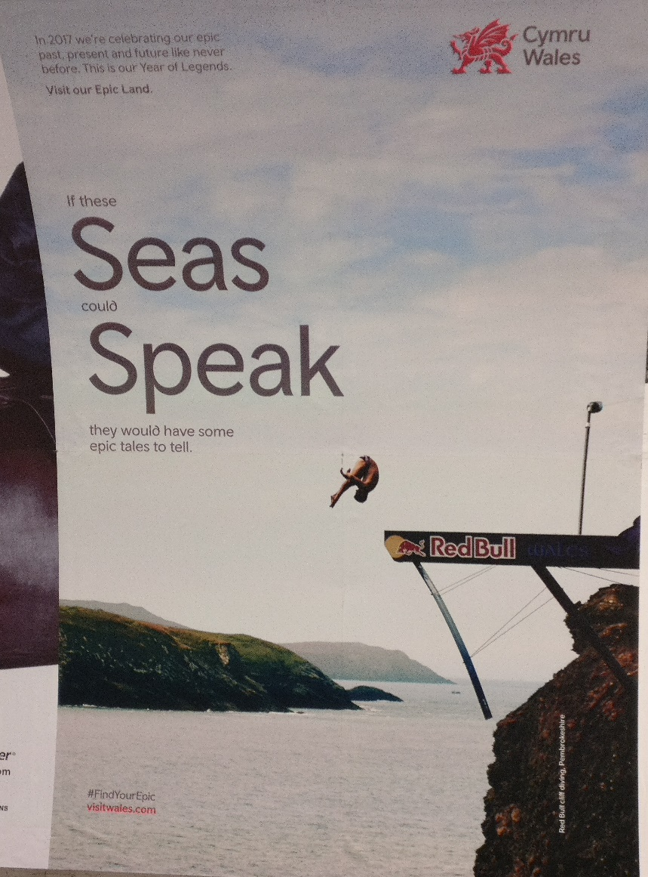
Tip:
This sentence is based on a famous English saying: “If these walls could talk…”, meaning that something bad or interesting has happened in a room and we don’t know all the details.
Imagine if the walls in the Oval Office could talk, what would they say?

I
Write a description of the picture:

Language Focus:
“If these seas could speak, they would have some epic tales to tell.”
- What words let you know this sentence is hypothetical?
- What word describes ability?
- What words would you change to change the meaning?

