Textploitation – Learning from Ads

Discussion:
- Why do people advertise?
- What kind of advertisements are there?
- Do you use adverts to practise English?
- Can you remember any popular ads from your country?
- Look at the questions above. What are the different ways of saying “advertisement”?
- Which is the most common when you are speaking?
- How do you pronounce them? Mark the stress on the words.
This advert is from the London Underground. Read it and answer the following questions:
- Who is advertising?
- What is the purpose of this ad?
- Why do you think they decided to print this ad?
- How does it make you feel?
- What kind of person do you think is telling the story?
Vocabulary focus:
- Verb: water comes from your eye because you are sad:
- Noun: Short for mother:
- Verb: Speaking loudly and angrily:
- Non: the London underground network:
- Noun (uncountable): People who work for a company:

Dictionary skills:
Examine the following words in their context. Think about what they might mean and then check your ideas in a dictionary:
- Advise - Polite - Abusing
- Swearing - prosecute - offenders
Rewrite the warning at the bottom of the advert in your own words.
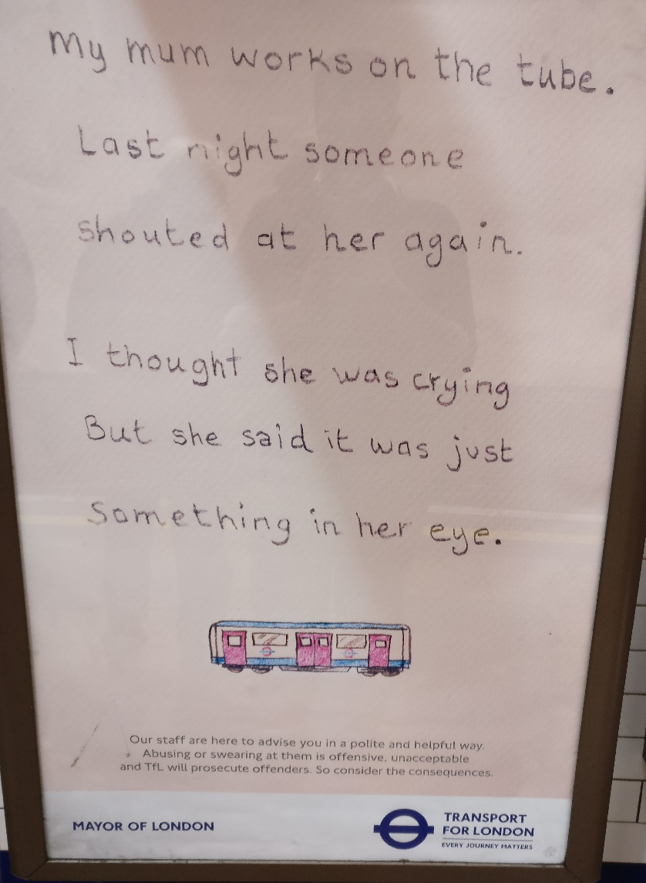

Comprehension:
- Is there something in her eye?

Language Focus 1: Story grammar
What tenses are used in the sentences below?
- My mum works on the tube.
- Someone shouted at her again.
- I thought she was crying
Why is each tense used?
Complete the rules below:
We use the _________ _________ to talk about situations that are always true. For example, someone’s ______.

We use the _____ _______ to talk about situations that are finished in the past.

We use the _______ ______________ to talk about situations that were in ___________ in the past.

(progress / present / simple X2 / job / past X2 / continuous)

Language Focus 2: Reporting speech
Can you find any speech in the advert? Is it direct speech or is it reported? How do you know?

When direct speech is written down, what do you usually have?
Can you complete the sentence below?
Can you add punctuation?

It ____ just something in my _____ said her mother

She said it was just something in her eye

Compare the 2 examples of speech, what are the differences between direct and indirect speech?
If you are telling a story, which is more common?

Practice:
Write a short short story about something interesting that’s happened to you on public transport.

