
This is Bob…but why do you think he is in the bin? What is he doing? Can you think of any possibilities?


What do you think he is doing?

Discussion:
- What have you read so far today? Meant to show that they have probably done more than they thought (e.g. ads / texts message / Facebook / etc.)
- Can you use advertisements to learn English?
- Do you ever use them? What do you do?

Read the advertisement below and answer the following questions:
- What is the name of the website being advertised? Gumtree
- What is it? It is a website on which you can sell your products
- What service is it offering? Allowing you to sell your products online
- Does this ad make you want to use the website?
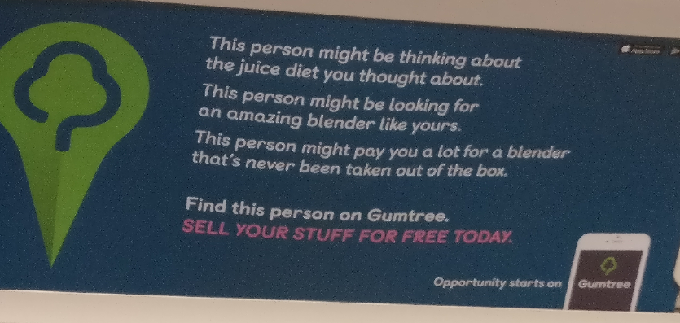

Language focus 1:
- Can you find a noun that means “things” (informal): stuff
- Is the above noun countable or uncountable? uncountable
- What do you think a “juice diet” is? A diet of healthy fruit / veg juices
- Using the context, what is a “blender”? What is the verb for this noun? A machine which turns fruit and veg into a juice. To Blend

Language focus 2: Might

Analyse the sentences in the ad above and complete the rules with the words below
(progress / possible / future x 2 / be / verb)
- Might is used to describe possible situations.
- In these examples “might” is used to describe possible actions in progress and possible future actions.

- Might + be + verb (ing) = possible actions in progress now
- Might + verb = possible future actions

Rewrite your ideas using “might”.

