Phrasal Verbs – putting them into use

1. What is a phrasal verb? (choose the correct answer)
- A verb and a preposition
- A collection of words which have a new and unique meaning together

2. Which of these are phrasal verbs?
- look into b) look at c) look for d) look up
Are there any that could be a phrasal verb and also can keep its original meaning?

3. How confident are you using phrasal verbs?
1 2 3 4 5

If you don’t use them why not?
________________________________________________________________________________________________________________________________________________________________________________________________

4. Are they normally used in spoken or written English more?

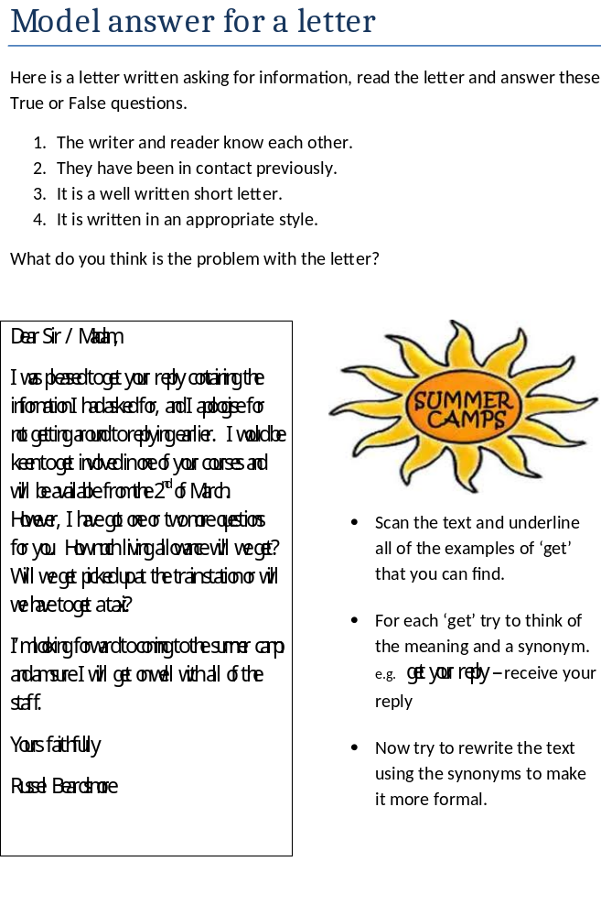Putting knowledge into action
get together hang out with catch up sort out
pop by looking forward to be up for it keen on

Sam,
Oh my god, it was lovely to meet you and talk at the weekend. Hearing about all your news was great and just getting to spend time with you was fantastic. Anyway, it was so nice I thought we should try to plan another time when we can meet. What do you think?
My idea is to get a group of us and then go for a picnic in the park, depending on the weather. Would you like to go? I’m not going to ask lots of people, just a small group, but I thought it would be great if everyone brought a bit of food and we could maybe take a few balls or games.
At the moment, I’m thinking about Sunday next week. Even if you are busy you could come for a short time. I’ll let you know if there people are interested in doing it later in the week.
I am excited about seeing you
Mark

Which phrasal verbs from the box could be used to replace the underlined words?
What is the effect of this change?

