Read through the story below (ignore the blank spaces). Where do you think Tom is going? Why is he going there? What do you think his relationship with Becky is?
It ________________ (rain) for hours but Tom couldn’t put it off any longer, he ____________ (grab) his umbrella and stepped out into the rain, letting the door slam shut behind him. He ________ (stand) on the front step, ___________ (put) up his umbrella and ___________ (walk) briskly towards the bus stop.
He couldn’t believe it had been so long since he’d seen them all, his heart _______________ (pound) in his chest.
What if they’ve changed, he thought, What if they ___________ (not remember) me, I__________ (be) so embarrassed.
He pushed those thoughts from his mind and stepped around a puddle. A car raced past him splashing dirty water all over his legs.
It’s a good thing I______________ (wear) my black jeans and not my cream ones, he thought, thankful that he _________________ (forget) to wash his cream ones.
An hour later he was much wetter and far more nervous than he had been when he’d left the house. It was 8:35, he wasn’t even fashionably late. Only a few cars were scattered around the car-park so he was one of the first to arrive. He couldn’t even manage to be fashionably late. Shaking the rain off his umbrella, he __________ (step) into his old school.
________________ (be) ten years? He thought. It _____________ (feel) like only yesterday that I graduated.
The first person he saw when he entered the hall where the party was going to take place was Becky. The next thing he saw was the bar.
I’m definitely going to need a drink before I talk to her, he thought as he headed towards the bar.
Vocab:  - Verb: to go in the direction of – head  - Noun: A small pool of water – puddle  - Noun: The place where you can buy  alcohol at a party / in a pub – a bar  - Verb: To close loudly – slam  - Phrasal Verb: To postpone – put off  - Verb: To beat quickly / strongly – pound | 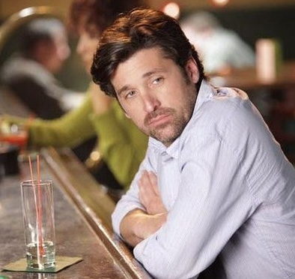

Tense review:
- Choose the correct form for the verbs in brackets above. Think carefully about why you are choosing each tense. When you are finished, check your answers on the next page.

It had been raining for hours but Tom couldn’t put it off any longer, he grabbed his umbrella and stepped out into the rain, letting the door slam shut behind him. He stood on the front step, put up his umbrella and walked briskly towards the bus stop.
He couldn’t believe it had been so long since he’d seen them all, his heart was pounding in his chest.
What if they’ve changed, he thought, What if they don’t remember me, I’ll be so embarrassed.
He pushed those thoughts from his mind and stepped around a puddle. A car raced past him, splashing dirty water all over his legs.
It’s a good thing I’m wearing my black jeans and not my cream ones, he thought, thankful that he’d forgotten to wash his cream ones.
An hour later he was much wetter and far more nervous than he had been when he’d left the house. It was 8:35, he wasn’t even fashionably late. Only a few cars were scattered around the car-park so he was one of the first to arrive. He couldn’t even manage to be fashionably late. Shaking the rain off his umbrella, he stepped into his old school.
Has it really been ten years? He thought. It feels like only yesterday that I graduated.
The first person he saw when he entered the hall where the reunion was going to take place was Becky. The next thing he saw was the bar.
I’m definitely going to need a drink before I talk to her, he thought as he headed towards the bar.

Language analysis:
- The first person he saw when he entered the hall where the reunion was going to take place was Becky.
- Why did the writer use “was going to” here? – future in the past.
- Is he referring to the past, present or future? – it is the future of a past situation

- Shaking the rain off his umbrella, he stepped into his old school.
- Why did the writer choose a present participle here? It avoids repetition of tenses
- Is this an on-going action? Not really, the shaking probably started as he stepped into the school
- Did these actions happen one after the other or at the same time? Same time.

Discussion:
- Have you ever had a school reunion?
- What do you think people would find most interesting about you? How have you changed?
- Would you be honest about your life or make up some stories?

