Cambridge English Dictionary’s definition of “Brexit”:
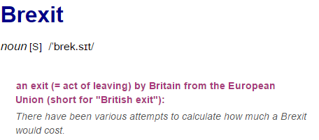
Today, 23rd June 2016, the British people queued up at polling stations to cast their vote and have their say. Soon we will know if Britain will remain in the EU or choose to exit and fend for themselves. Here are some opinions of British citizens on the referendum.

Chunks of language:
- Verb phrase: to stand in a line and wait for something –
- Verb phrase: to vote officially for something –
- Verb phrase: to get the opportunity to tell people your opinion –
- Verb phrase: to survive on your own –

Discussion:
- What do you know about Brexit?
- Do you think Britain should leave the EU?
- What do you think are the major reasons people might want to stay?

Reading:
- Read through the opinions on the opposite page and decide if each person is going to vote “in” or “out”. Discuss each one with your partners.

Vocab:
- Paul: verb phrase – fix a problem –
- Mike: noun – fear or hatred of foreign people –
- Mike: verb phrase – to force someone to do something –
- Remainer: noun – ten years –
- Remainer: noun – people who live and work in a foreign country –
- Scotia: Adjective – shocking and bad –

