Reading:
- Read the song below and discuss the story with your partner. Who is the singer speaking to?
- Do you think he will be a good father?
- What is his attitude towards traditional education?

Kooks by David Bowie
(Chorus x 2)  Will you stay in our lovers' story  If you stay you won't be sorry  'Cause we believe in you  Soon you'll grow so take a chance  With a couple of Kooks  Hung up on romancing | And if you ever have to go to school  Remember how they messed up  This old fool  Don't pick fights with the bullies or the cads  'Cause I'm not much cop at punching other people's Dads  And if the homework brings you down  Then we'll throw it on the fire  And take the car downtown
We bought a lot of things  To keep you warm and dry  And a funny old crib on which the paint won't dry  I bought you a pair of shoes  A trumpet you can blow  And a book of rules  On what to say to people  When they pick on you  'Cause if you stay with us you're gonna be pretty Kookie too  (Chorus) | (Chorus x 2)  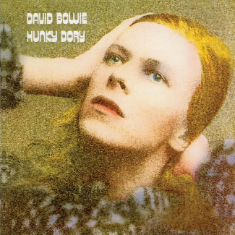

Vocabulary:
- Phrasal verb: a little obsessed with –
- Adjective: strange / odd
- Phrasal verb: to bully / to make fun of –
- Adverb: quite –
- Phrasal verb: made a lot of mistakes / ruined something –

Old-fashioned words:
- Kookie = odd / eccentric
- I’m not much cop = I’m not very good at
- Cads = a playboy

Discussion:
- What do you think of the song?
- Which of the following facts about the song do you think are true:
- Bowie wrote it to his unborn child.
- The English band, The Kooks, took their name from this song.
- Bowie’s child was called Zowie but then changed his name to Duncan.
- That child is now a famous Hollywood director.
- Do you think songs can be used to learn about pronunciation?

Pronunciation (Weak forms)
Listen to the chorus carefully and decide how the following underlined words are pronounced:
Will you stay in our lovers' story
If you stay you won't be sorry
'Cause we believe in you
Soon you'll grow so take a chance
With a couple of Kooks
Hung up on romancing
Are they pronounced as you would imagine? Are they always pronounced the same? Use the examples above to complete the rule below.
Words like ____________, ____________ and ______________ are very often ____________ to weak forms in natural speech. We very often use the ________ when pronouncing them.
(articles, schwa, reduced, pronouns, prepositions)

Pronunciation (linking)
Listen to the chorus again, is there any linking between the following words:
Will you stay in our lovers' story
If you stay you won't be sorry
'Cause we believe in you
Soon you'll grow so take a chance
With a couple of Kooks
Hung up on romancing
Using the examples above, complete the rule below:
When one word ends in a ______________ sound and the next word begins with a _____________ sound, those words are very often ____________ in natural spoken English.

Pronunciation / Listening
Read through the song and mark any other words you think might be linked or weak forms. Listen to check.

Language Analysis
Underline all of the uses of “will” and “won’t” in the song. How are they being used?
- Requests? - Future decisions? - Promises? - Predictions?

