Paint it Black – Listening
What associations do you have with the colour ‘black’?

Which of the following things does the singer want to paint black, or say are already black?

Add them to the correct place in the table. Which one is doesn’t fit into either of the two columns

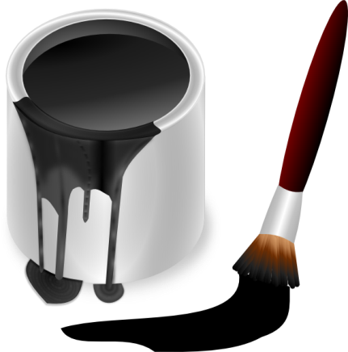
- red door
- girls
- cars
- colours
- heart
- your(his) whole world
- the sun

Wants to paint it black | Already black

Grammar and Vocabulary

“I see my red door I must have it painted black”

Who is going to paint the door, the singer or someone else?

Structure: to have something + p.p.

This grammar structure is often used when we pay people to do something for us
For example: To have my hair cut / to have my car fixed / to have my nails done
If you want to be informal you can use _____ instead of ‘have’
Example: I ____ my door painted black yesterday.

Vocabulary – building phrases and working out meaning from context

Complete the phrase using a word from the song’s lyrics

- ______ more
- a ______ of cars
- to ______ back
- look ______ myself
- fade ______
- ______ the facts
- Facing ______
- Look ______ enough
- Walk ______
- ______ my head

In groups check what these mean in the context of the song, can you think of a synonym for them?

Pronunciation –

Listen to the way ‘happening’ is pronounced. How many syllables are there?

/ /

This is different from the normal pronunciation which is only two syllables.

/hæpnɪŋ/

Pronunciation – linking sounds

- I see a b) I see the

Which sound goes between ‘I’ and ‘see’ - /w/ or /j/?
This happens because in English it is hard to say two vowel sounds together fluently.

Song Lyrics "Paint It Black" –

The Rolling Stones
I see a red door and I want it painted black
No colours any more, I want them to turn black
I see the girls walk by, dressed in their summer clothes
I have to turn my head until my darkness goes
I see a line of cars and they're all painted black
With flowers and my love both never to come back
I see people turn their heads and quickly look away
Like a new-born baby, it just happens every day
I look inside myself and see my heart is black
I see my red door I must have it painted black
Maybe then I'll fade away and not have to face the facts
It's not easy facing up when your whole world is black
No more will my green sea go turn a deeper blue
I could not foresee this thing happening to you
If I look hard enough into the setting sun
My love will laugh with me before the morning comes
I see a red door and I want it painted black
No colours any more, I want them to turn black
I see the girls walk by, dressed in their summer clothes
I have to turn my head until my darkness goes
Hmm, hmm, hmm,..
I wanna see it painted, painted black
Black as night, black as coal
I wanna see the sun blotted out from the sky
I wanna see it painted, painted, painted, painted black
Yeah!

