'When I'm sixty-four... years on the throne': Queen serenaded by children singing classic Beatles song to mark her 64 years as the nation's longest-serving monarch.

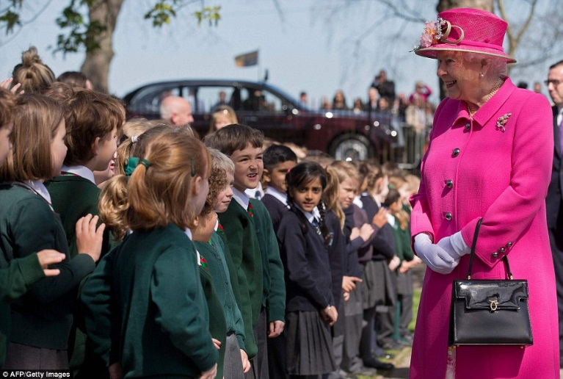

By REBECCA ENGLISH, ROYAL CORRESPONDENT and LUCY CROSSLEY FOR MAILONLINE
She's never been one to enjoy a fuss so her visit this morning to Windsor's Royal Mail delivery office and a plaque unveiling at her new local bandstand were actually fairly run of the mill royal engagements. The only clue to the fact that the Queen is about to celebrate a very special event tomorrow came with not one but two renditions of Happy Birthday - and a spirited rendition by local schoolchildren of a cheeky When I'm 64.

In Alexandra Gardens, just a stone's throw from her home at Windsor Castle, she smiled appreciatively as a children's choir performed four short songs for her - including Red Red Robbin (written in 1926, the year of her birth) and English Country Garden - followed by a brief and very modern interpretation of a scene from Romeo and Juliet by children taking part in the School's Shakespeare Festival.

Indeed just hours short of her 90th, the monarch skipped up the steps to the bandstand, accompanied by her 94-year-old husband, the Duke of Edinburgh, in the glorious spring sunshine. The structure has been built to celebrate the unique and longstanding links between the Queen, the armed forces and Windsor with a grant from the Armed Forces Community Covenant. It features six commemorative plaques focusing on the role of the Armed Forces, and is edged in an ornate regal purple trim. It also commemorates the Queen as the longest reigning monarch in British history and consequently the longest serving Head of the Armed Forces.
Both the Queen and her husband smiled as they met some of the schoolchildren, and applauded politely as they watched the hundreds of youngsters perform the Beatles track with gusto, accompanied by the Band of the Irish Guards dressed in their red tunics. The song was picked to mark the nation's longest-reigning monarch's 64 years on the throne.

Vocab:
- Noun: trouble / bother –
- Phrase / expression: normal / average –
- Phrase / expression: close to / not far from –
- Adjective: short / quick –
- Verb: Clapped their hands –
- Prepositional phrase: to do something with great energy / enthusiasm –
- Adjective: funny but in a slightly disrespectful way –

Comprehension:
- Why did the children sing this particular Beatles song?
- What was the bandstand built to celebrate? How does it do this?

Discussion:
- Does your country have a monarchy?
- Is the British royal family famous in your country? What do you know about them?
- What do you think would be the advantages / disadvantages of having a monarchy?
- What would you do if you were the Queen/King?

What does the British public think?

Check out the comments below. Without using your dictionary, summarise their opinions with your partners.

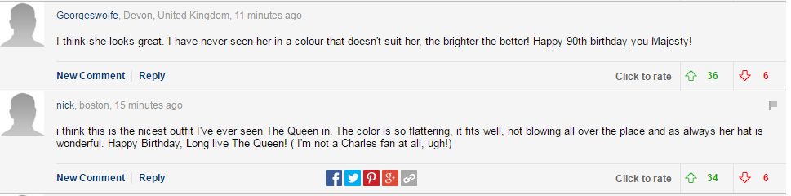
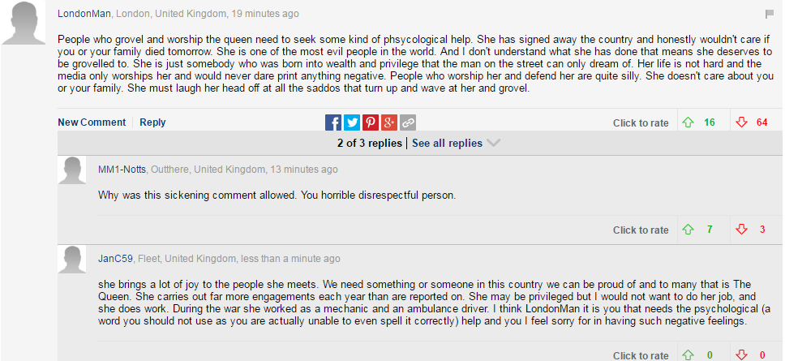

Vocab (what do you think the words / phrases below mean?):
- “I have never seen her in a colour that doesn’t suit her”
- “people who worship her and defend her are quite silly”

