Rush-Hour Crush
Scan the text below and with your partner, decide where it is from?
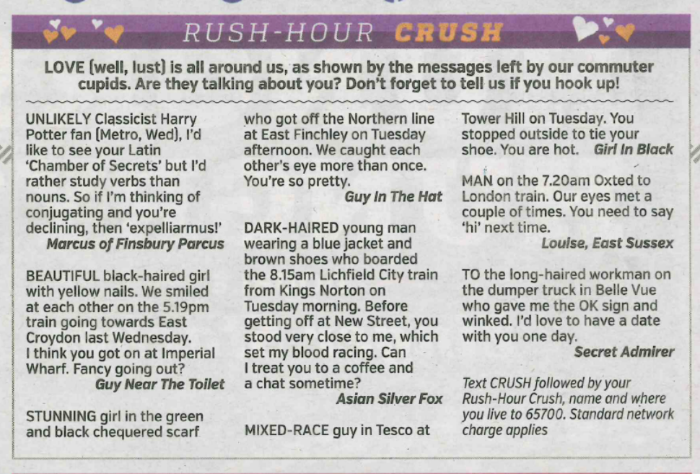
Google “rush hour crush metro” to check your answers.
What do you think of this?
Do you have anything similar in your cities?

Reading Comprehension:

Scan the text above and match each message to a number below:
- Makes a reference to a fantasy novel.
- Describes someone who made contact but didn’t speak.
- Describes someone’s outfit.

Vocabulary:
Match the definitions below to appropriate words and phrases in the text.
- Verb: prefer –
- Noun: a relaxed discussion –
- Adjective: someone whose parents have different skin colours –
- Verb: got on a train –
- Adjective: Beautiful –
- Noun: A romantic meeting –

Using the context to help you, decide what the phrases below mean:
- “Fancy going out?”
- “…which set my blood racing”
- “…gave me the OK sign”

Language focus:
Read the definition of a noun phrase below.
Examine the extracts below. Can you identify the noun phrases in each one?
A noun phrase includes a noun—a person, place, or thing—and the modifiers which distinguish it.
You can find the noun dog in a sentence, for example, but you don't know which canine the writer means until you consider the entire noun phrase: that dog, Aunt Audrey's dog, the dog on the sofa, the neighbour's dog that chases our cat, the dog digging in the new flower bed. (taken from chompchomp.com)

“Stunning girl in the green and black chequered scarf who got off the Northern line at East Finchley on Tuesday afternoon. We caught each other’s eye more than once.”

“Beautiful black-haired girl with yellow nails.”

“Dark-haired young man wearing a blue jacket and brown shoes who boarded the 8:15am Lichfield City train from Kings Norton on Tuesday morning.”

Find:
- A hyphenated compound adjective
- Two words which can be used to describe someone’s clothes
- A relative clause
- A word which can be used to describe someone’s appearance / makeup

Using some of the ideas below. Try to make the longest noun phrases you can from the basic sentence below. See if you can do better than the other groups.
The man kissed the girl.
______________________________________________________________________________________________________________________________________________________________________________________________________________________________________________________________________________________________________________________________________________________________________________________________________

