Pre-Reading discussion Questions:
/ˈledʒənd/
noun
- 1.a traditional story sometimes popularly regarded as historical but not authenticated.
"the legend of King Arthur"
synonyms: | myth, saga, epic, folk tale, folk story, traditional story, tale, story, fairy tale, narrative, fable, romance

- Do you know of any British legends?
- Are there any legends where you are from?

The Legend of the Barcelos Cockerel.

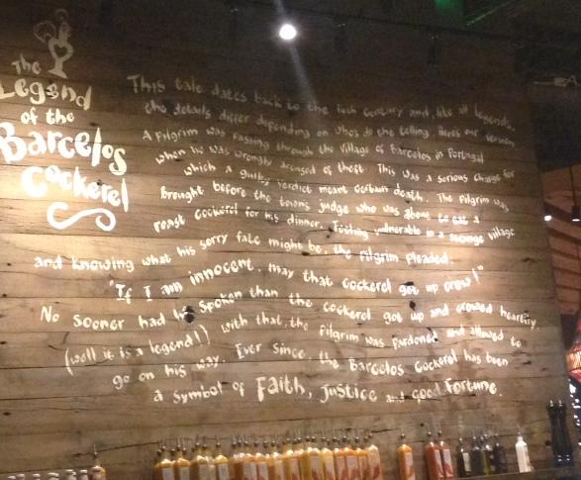

This tale dates back to the 14th century and, like all legends, the details differ depending on who’s do the telling. Here’s our version:
A pilgrim was passing through the Village of Barcelos in Portugal when he was wrongly accused of theft. This was a serious charge for which a guilty verdict meant certain death. The pilgrim was brought before the town’s judge who was about to eat a roast cockerel for his dinner. Feeling vulnerable in a strange village and knowing what his sorry fate might be, the pilgrim pleaded: “If I’m innocent, may that cockerel get up crow!”
No sooner had he spoken than the cockerel got up and crowed heartily, (well it is a legend) with that, the pilgrim was pardoned and allowed to go on his way. Ever since, the Barcelos Cockerel has been a symbol of Faith, Justice and Good Fortune.

Reading:
- Skim read the text and retell it to your partner. Help each other to fill in the details.

Vocabulary Focus:
- Noun: Someone who travels to holy / sacred / important places (often on foot): pilgrim
- Verb: told that you are innocent / that you didn’t commit a crime you were accused of: pardoned
- Noun: A male chicken: cockerel
- Noun: Belief: Faith
- Noun: Luck Fortune
- Adjective: opposite of innocent: guilty
- Noun: the person who decides punishment in legal cases Judge

Editing:
- Sadly, even though this was written on the wall of an English restaurant, the writer has made 3 errors, which highlights the need to check your written work before you hand it in.

Reread the text and see if you can find them. Use the clues below:
- A grammar error: who’s DOING the telling
- A missing word: may that cockerel get up AND crow
- A questionable capital letter: There is no reason for the ‘v’ in “the Village of Barcelos” to be capitalised.

Keep an eye out for mistakes on menus, signs and advertising. Try correcting them yourself. Start with this one below:
every day = discussion frequency
everyday = an adjective meaning average / normal


Language Focus:
“No sooner had he spoken than the cockerel got up and crowed”
- What do you notice about the word order in the sentence above? – the subject and the auxiliary are inverted
- What is the effect on the reader? Why has the author chosen this structure? – It highlights the immediacy of the action and grabs the reader’s attention. They know something surprising is coming
- Would you find this structure more commonly in written or spoken English? Why? – this is usually used in stories, especially written stories as it keeps that interest going.
- Complete the pattern, using the words below:

No sooner had (Someone) + past participle than (clause)

(Past participle / someone / clause)

