Discussion Questions:
- English speakers “eat their words”. True / False? – This is what I often hear from students but we want them to think a little deeper about what they mean.
- If you answered TRUE for question 1, be specific, what exactly do English people do? Why do they do it?
- We can and should learn how native speakers speak English – discuss – Even if they don’t want to speak in this way, they need to understand spoken English.

Giving Advice:

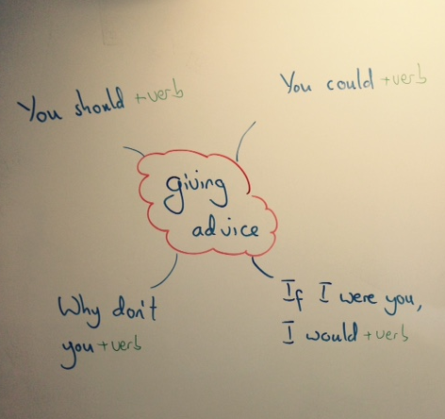

Using the advice forms above, write some advice for your teacher.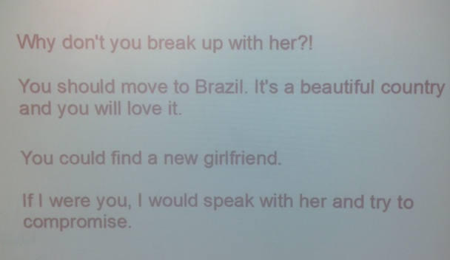
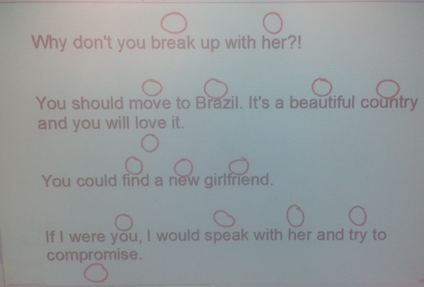
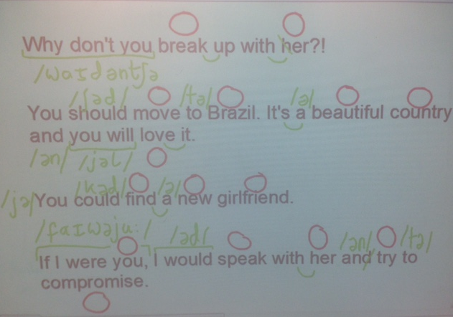

Sentence Pronunciation Guidelines:
- In English, CONTENT words are usually stressed. E.g. NOUNS, VERBS, ADVERBS and ADJECTIVES.
- Most “grammar” words (articles, pronouns, prepositions) are UNSTRESSED. They are called WEAK forms and often contain the sound ,which is called THE SCHWA
- When one word ends in a CONSONANT sound and the next word begins with a VOWEL sound, the two words will be linked.
- When one word ends in a CONSONANT sound and the next word begins with a similar CONSONANT sound (e.g. /d/ + /t/), the first sound will disappear and the two words will be LINKED.
- The final word in a CLAUSE or a SENTENCE is usually stressed, even if it is a PRONOUN.
(Linked / Consonant x 3 / Vowel / Content / Clause * / Verbs / Weak / Adjectives / / Nouns / The Schwa / Adverbs / Unstressed / Sentence / Pronoun)

* A clause is part of a sentence.
You should go home. = 1 sentence with 1 clause.
You should go home and you should speak with your girlfriend. = 1 sentence with 2 clauses.

