Star Wars

may the grammar be with you - always
Word Order

Yoda, jedi master, all-round good guy, but dodgy word order. Let’s see if you can help him by correcting the word order in these quotes,

1) “Powerful you have become, the dark side I sense in you.”
You have become powerful. I sense the dark side in you

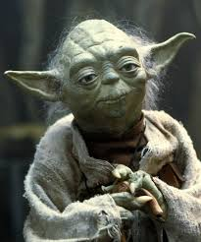

Good work, now try something a little longer. – underline the sections which have unusual word order and try to correct them.

“Yes, a Jedi’s strength flows from the Force. But beware of the dark side. Anger, fear, aggression; they are the dark side of the Force. They flow easily and are quick to join you in a fight. Once you start down the dark path, it will dominate your destiny forever, it will consume you, as it did Obi-Wan’s apprentice.”

Comparatives



Princess Leia
Great lady and lovely grammar.

https://www.youtube.com/watch?v=-wntX-a3jSY

Try to complete the quote and then listen to check.

“The more you tighten your grip, the more star systems will slip through your fingers”

The + comparative + clause, + the + comparative + clause

- The more I practice, the __________________________________
- The longer I live in _____________, the _____________________
- The _________________________, the _____________________

As if / like

obi Wan Kenobi – Wise in the ways of the force and grammar

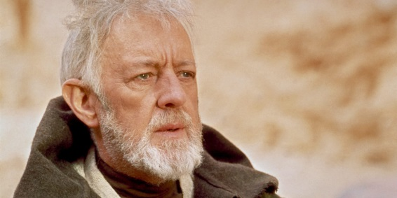
"I felt a great disturbance in the Force, as if millions of voices suddenly cried out in terror and were suddenly silenced."

Here we could use as though instead

But, how could we change this sentence if we wanted to use the word ‘like’?
check the grammar box below then write

I felt a great disturbance in the force like millions of voices suddenly crying out in terror and then being silenced

as if / as though / like
Circle the correct option.

Traditionally, ‘as if’ and ‘as though’ are followed by a noun / clause. However, ‘like’ is normally followed by a noun / clause.
But increasingly, people are using like with clauses. E.g. it looks like it is going to rain.

Real / unreal conditionals

Read the quote below, which word could be used to replace ‘shall’ with no change in meaning?

“You can't win, Darth. If you strike me down, I shall become more powerful than you could possibly imagine.”

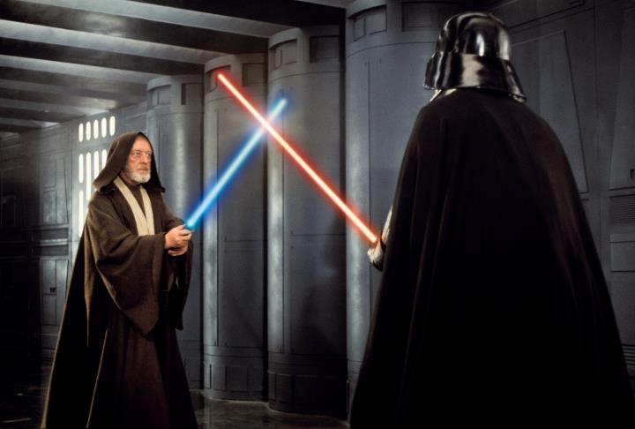

Real / unreal conditionals

Real - If + present, + future
Real – if you strike me down, I shall become more powerful than you could possibly imagine.
Unreal – If + past simple, + would / could / might
Unreal – If you struck me down, I would become more powerful than you could possibly imagine.

How are the two sentences different in meaning?
2nd is less real and less likely to happen
Inversion for emphasis

Emperor Palpatine
Evil, but.. Great Grammar
“Only now, at the end, do you understand. Your feeble skills are no match for the power of the Dark Side!”
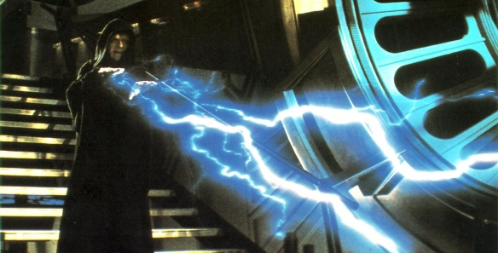

How could this be rewritten to be less dramatic?
You only understand now at the end. Your feeble skills are no match for the power of the dark side.

Written records – underline the correct choice
When we use ‘only’ to add emphasis it is followed by a time phrase / inversion. The second clause is a time phrase / inverted.
__________________________________________________________________________
Only
aux
main verb
sub
when + time clause
now
at

+ + + +

Personalisation
Only when I ………………….. will I be able to …..
Only now ………………………. do I ………………….

Reflection
When and where do you think you could use this structure?

Jar Jar Binks – Mostly annoying, and speaks in a unique way

How do you think the following line could be rewritten? Fill in the three missing words.

Hmmm… yousa point is well seen.
I know what you mean.

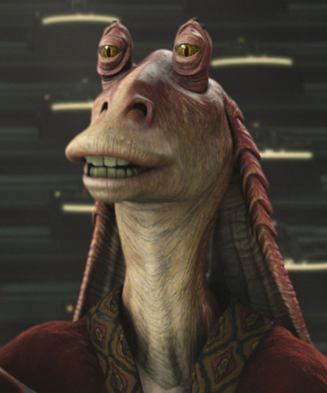
Now look at the following text, rewrite it so that you get the meaning, don’t worry about every single word.

I don’t know. Mesa day startin pretty okee-day with a brisky morning munchy, then BOOM! Gettin very scared and grabbin that Jedi and POW! Mesa here! Mesa gettin’ very very scared!

I don’t know. My day started pretty well with a short breakfast and then suddenly Boom. I got very scared and grabbed that Jedi and then I was here. Now I am very very scared.

Speed Reading – The opening

https://www.youtube.com/watch?v=UKRIUiyF0N4

"It is a period of civil war. Rebel spaceships, striking from a hidden base, have won their first victory against the evil Galactic Empire. During the battle, Rebel spies managed to steal secret plans to the Empire’s ultimate weapon, the DEATH STAR, an armored space station with enough power to destroy an entire planet.

Pursued by the Empire’s sinister agents, Princess Leia races home aboard her starship, custodian of the stolen plans that can save her people and restore freedom to the galaxy…."

