
CPD Session
February 20th / 27th 2013
“The write stuff”
Lesson ideas

Mini Sagas
Editing task - essay

Model letter for register
Model story for language
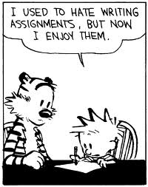
Mini Sagas

Here is the basic plot of a famous film, which film is it?

In the beginning a boy works on a farm. His life changes dramatically when he meets an old man who trains him as his apprentice. The old man is killed by a frightening villain. So he joins a group of freedom fighters and they manage to defeat their evil enemies.

- How many words are used? What grammar structures are used to avoid writing too much?
- When would writing a limited number of words be useful to you?

Think of a film you know well.
Choose the 5 most important points in the plot.
- ________________
- ________________
- ________________
- ________________
- ________________
Now write your mini saga, remember it has to be exactly 50 words!

Whatever your age, life in the country is always better than life in the city.
There's a 1______ of opinions about where life is better but in my opinion, the advantages are greater than the disadvantages if✓ you live in the city.
In the cities there're more options that you 2______ choose. The important building are usually in the center, where everybody can arrive. There are also more activities, what is more✓, if you are a teenager the city is 3______ amazing✓, because it's bigger, there's more party, but if you're an adult it 4______ also be better, because your office 5______ probably be there and there are more clubs and restaurants.
On the other 6______✓ the city is sometimes stressful✓✓, because there's a lot of noise, traffic jams✓✓ and people. There's another problem✓✓ which is, if you come from the country, you will think life is very complicated✓✓ in the city, and you won't probably ^{wo} like 7______. Living in the city it is not 8______ good idea for ancient^{v} people. People^{R} in the countries are normally more friendly, so while they're having a rest, they can be talking with another people who maybe will be more relaxed than people in city. Another point✓ is that they only 9______ basic services in the country-.

To sum up✓ I would choose living in the city, because I think it is more enjoyable✓, whereas I could maybe feel bored in the country. I also think 10______ you're studing^{SP} a career^{V} you should live in the city, because ^is the place where you will have more opportunities. ✓

Read through the modal essay and try to work out the missing words.

1.
2.
3.
4.
5.
6.
7.
8.
9.
10.

Look at the parts that have correction codes or are underlined and explain what the problems might be? How can you correct them?

Put these words into logical groups
However additionally although so therefore because despite
while Moreover but what is more while

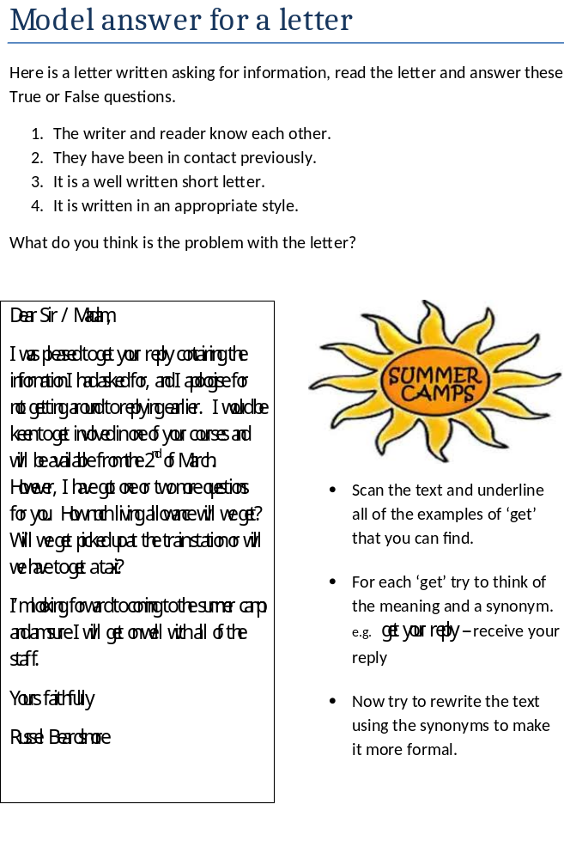Model answer for a story
It was an ordinary day, I was walking to school when suddenly, I saw it. It was beautiful, shining in the early morning sunlight. I had never seen anything like it before. I stood still and stared as it hovered above me in the blue, cloudless sky. Then, it was gone.
I rubbed my eyes and began walking again. As I walked I was thinking about what I had just seen and how I could tell my friends. If I did tell them, would they believe me? I stopped to get a coffee and as I sat drinking the coffee my mind continued playing the pictures I had seen again and again. I felt as if I would scream. I drank the last drops of coffee, threw my cup in the already half-full recycling bin and began to wander towards school.

Read the story, what do you think ‘it’ was?
Underline all of the examples of the three narrative tenses

Past simple –
Past continuous –
Past perfect –

Mark them all on the timeline shown below

the now
past

I saw it

Grammar Hunt

Scan the text and see if you can find an example of:

A conditional
Modal verb
Words that show time
Verb followed by ‘gerund’
Verb followed by ‘to inf’



Vocabulary
- Can you find an example of:
- A verb describing how the object looked
- A verb describing how the object moved
- An adjective to describe the sky (2 possible)
- A phrase that shows the main character was unsure about what he had seen?
- A partial synonym for walk, do you know how its meaning is different?

What has the writer done to make the story more interesting?

Vocabulary

Sentence structure

