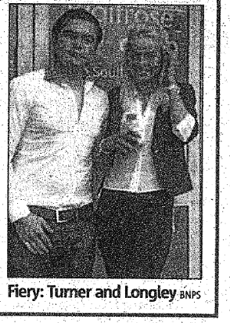
Evil’ boyfriend faces life for Killing teenage lover
Using the headline and the picture, what do you think this article is about?

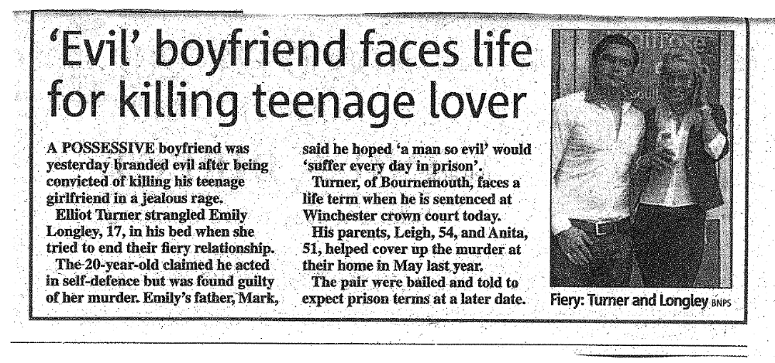
Read the article quickly and check your ideas.

Vocab focus (match the words below with words / phrases from the text):
- Adjective – bad:
- Noun – extreme anger:
- Noun – the two people / the couple:
- Noun – the crime of killing someone:
- Time phrase – in the future:
Underline any words to do with crime / court / prison in the article. Can you figure out the meaning from the text?
Discussion
- Have you ever heard of any other cases like this?
- Do you think he should go to prison or could you think of another punishment?
- Do you think the writer is totally objective? Why?
Language Focus:
“A possessive boyfriend was yesterday branded evil after being convicted of killing his teenage girlfriend…”

- What verb form follows the word “after”?
- What verb form follows the verb phrase “to be convicted of”?
- Can you find any other verb patterns in the text?

“A possessive boyfriend was yesterday branded evil…”

- Who branded the boy “evil”?
- Could you rewrite the above sentence segment in the active voice?

